Week 2: Asynchronous Design Studio

Team Building and Lessons Learned

Overview

After spending a week getting acquainted with the course learning objectives, projects, and your teammates, it is time to dive deeper into the initial steps of your project. For this week’s activity, the focus will be on learning about your own personality, highlighting what you have learned so far in your undergraduate career and planning ahead.

Stage 1: Personality Test

In your first asynchronous activity, you did some research on The Big Five personality test. Now, it is time for you to perform the test on your own. This test will help you learn more about yourself and your team member and improve your team engagement. Please remember that the test is simply meant to help you better understand yourself and your peers, learn about your personality preferences, your strengths, potentials, and interests. So, there are no right or wrong answers, and one personality type is not better than another! Please also be mindful that you are still developing your personality as a young engineering student which means that your results now are most likely going to be different than 5 years down the line.

Please navigate to [Big Five Personality Test](https://bigfive-test.com/test)  to perform the test and save your results to fill up the following section. You will be discussing these results with your team members during the synchronous session.

Please paste the visual summary of your results.

|  |
| --- |
|  |

In percentage, how accurate the results matched your personality?

100%

x 75%

50%

Less than 25%

What part of the results did you find inaccurate?

|  |
| --- |
| Observing the results, it was reported that a high anxiety and self-consciousness score contributed to my high neuroticism score. I’d have to disagree with these results, since I find that I am very rarely stressed when doing assignments, tests, exams, and in social circumstances. I usually feel more laid back and tend to go with the flow. Also, I have a lot of confidence in my ability, so I disagree with the self-consciousness point on that front. During previous groupwork in 1P13, I did not find myself feeling self-conscious when describing my ideas and suggestions to my groupmates. Rather, I found I was making a relevant contribution that would be of great help to the group. I wouldn’t describe myself as a self-conscious person in this situation, though I do feel more self conscious in an environment like the gym. |

What surprised you in the results?

|  |
| --- |
| The high self-consciousness score/anxiety score outlined previously surprised me since I disagree. However, I thought the openness score was underwhelming. I know that I am not a person who is open to big changes and enjoy routine, but I am open to new ideas and technologies, as well as learning new and interesting things. Finally, my extraversion score was unusually high. I don’t consider myself to be socially inept, but I certainly do not consider myself to be an extrovert. Most days I prefer to work alone and have lots of personal space and quiet. However, I do enjoy social settings and events, so I can see where the high score came from. |

What did you learn about yourself that you didn't know?

|  |
| --- |
| I didn’t know I had so much trust in people. My agreeableness score was very high and I was surprised to see I had such a high trust score. I always thought that one of my greatest flaws was a lack of trust in groupmates, teammates, and co-workers. However, it seems that my answers indicate that I trust others easily. Reflecting on this, I now agree with these results. I tend to trust people I’ve just met easily (if not TOO easily), and I feel like this ends up working against me, since my trust in my groupmates to do their part was not always fulfilled in previous projects. |

Name one way that this test can help you better interact with others.

|  |
| --- |
| With the results, I can now be more conscious of what I do and the effect of my actions on myself and others. As outlined previously, the high trust score (and low cautiousness score) indicates to me that I should be more careful when putting my trust in others. Also, the low self discipline score is a good reminder to stop and think before I get attached to a particular idea. In addition, my low vulnerability score tells me that when times get tough, I have the ability to stay cool and keep my group focused on the goal. |

Based on the results, what are your strengths?

|  |
| --- |
| Based on the results, my strengths are my agreeableness traits (high trust, morality, altruism, modesty, and sympathy), as well as my extraversion traits (friendliness, excitement-seeking, cheerfulness). While I may disagree with some of these traits, I find others to be very true and I hope that they serve me well during the coming project. |

Based on the results, what would you like to improve?

|  |
| --- |
| Based on the results, I’d like to improve my neuroticism score by working on my self-control and self-consciousness. I find myself jumping to conclusions and overindulging in things too often, and it would be of great use for me to reduce these tendencies. I’d also like to improve my openness to experience by allowing my mind to wander more and exercising my creative side more often. I used to do artistic and creative things like draw and create videos, but I let those habits go when I began university. |

Stage 2: Equity, Diversity and Inclusion

During your synchronous Design Studio, you will be doing an activity on Equity, Diversity and Inclusion where you evaluate different scenarios. In order to prepare for this, please watch the EDI video series found on Avenue to Learn under [Table of Contents → 4-Design Studios →Week 2 → Wk-2 - EDI Videos]

Please write down your video notes below.

|  |
| --- |
| * Diversity is being invited to the party, inclusion is being asked to dance   + Need people with different skill sets and experiences to recruit as many different people as possible (Diversity)   + Introducing newcomers to others, checking in on them, inviting them to more events where they will get to know more people, are all elements of the party analogy that show inclusion * Inclusion is the set of actions people take to ensure we get the same opportunities for success as everyone else   + Back to metaphor, belonging is being able to dance however you want, equity is being able to pick the DJ   + Each person should be able to let their personality shine and still be respected and treated fairly * Equity is about the power of decisions made behind the scenes (who picked the DJ) * Best practices of diversity and inclusion lead to best outcomes of belonging and equity * We want people to feel like they are valued and wanted   Privilege   * Social identity: how you think about yourself and what groups you identify with * Identities that you overlook or do not consider are usually ones where you have privilege * A strong example is the prevalence of racism in our society * It is important to observe how one’s privilege can impact their experiences * The most important thing is to acknowledge that we have privilege   Why do people say and do the wrong things?   * We have a unique way of seeing the world, and sometimes saying things from our point of view can be offensive to others * Many people have unconscious bias, which makes an appearance in what we say * Our inability to acknowledge our privilege can offend others   + Not noticing how difficult something is for another person because we don’t experience that difficulty * Trying to “do and say the right thing” can come off as inauthentic * Saying nothing is not a great strategy * “You’re always going to feel uncomfortable before you become comfortable with difference” * Ignoring difference can be detrimental   + Don’t pay attention to difference in a way that will make it more difficult for that person * People who are underrepresented might be having a different experience in a workplace or interview * All of us have to be willing to move forward in understanding how to talk to each other about difference   What can you do even if you say or do the wrong thing?   * Its okay to make mistakes, you probably WILL make mistakes   + Its about connection not perfection   + If you say the wrong thing, just apologize * Feedback is a blessing: for example, “I found your tone hurtful” * Empathy towards the person is more important that clarifying your intent * Educating yourself to improve your ability to avoid saying the wrong thing * Learn from your mistakes   + Always look for suggestions and feedback to improve |

Stage 3: Time and Stress Management

As you have experienced in your undergraduate years so far, engineering workload is very heavy and requires discipline and time management. This why it is very crucial to plan your schedule ahead of time and examine all the time and stress management techniques that you can utilize. Please watch the **Time and Stress Management** video on Avenue to Learn under [Table of Contents → 4-Design Studios →Week 2 → Time and Stress Management]

Please write down your video notes below.

|  |
| --- |
| * 87% of students said they could do better in school if they managed their time better   Parkinson’s law   * Work will expand to fill in the time allotted for its completion * Setting artificial deadlines and block timing will help you finish work faster * Reward yourself for finishing within an artificial deadline   Eat the frog   * Tackle most important tasks first * Assignments worth more are of higher priority   Pomodoro technique   * 25 minutes of focus, 5 minutes of break * Repeat 4 times, then take a 30-minute break * You will be more productive * Breaks down large tasks into easier-to-digest and small chunks   Scheduling   * Plan out your week on a calendar * Eat the frog   Sustainability   * Diet and exercise * Good eating habits, at least 30 minutes of exercise daily |

Aside from online learning, what are the 3 most stressful experiences you have had in your first year? (Specifically, ENGINEER 1P13)

|  |
| --- |
| 1. Final design studio. I woke up late for the video submission and my group almost submitted a copy they recorded without me. This could have been avoided if I managed my time better and didn’t stay up late doing assignments. 2. Programming section on the midterm. I had never programmed before 1p13 and was having difficulty understanding the content. If I were to eat the frog instead of avoiding programming and focusing on 3D modelling, then maybe I would have been more prepared. 3. My overall lifestyle. Throughout the first semester of first year I was constantly leaving things to the last minute, wasting time, and ignoring important tasks. Looking back it was obvious I lacked motivation and focus. So, in second semester I changed my lifestyle, began exercising regularly, tried my best to eat healthy and get an appropriate amount of sleep every day. This greatly boosted my motivation and work ethic as I felt like I was rewarding myself. |

If you were to do ENGINEER 1P13 again, what would you have done differently to alleviate that stress?

|  |
| --- |
| I would have employed every strategy possible to improve my time management. I spent way too much time doing nothing (watching tv, playing video games, etc), when I should have been reviewing material and preparing myself more effectively for presentations, tests, and assignments to come. |

Stage 4: 1P13 Lessons Learned

Before doing this stage, please watch the **1P13 Lessons Learned video** on Avenue to learn under [Table of Contents → 4-Design Studios →Week 2 → 1P13 Lessons Learned Video]. In your first year, you participated in one of the biggest courses to be taught at a university! ENGINEER 1P13 mostly focused on the technical aspect of engineering design as well as human centered design. You had the opportunity to work on 4 projects that developed your skills in various fields and taught you some of the most useful design tools. As learning about the engineering design process never ends, you are moving on to learn more about design in ENGINEER 2PX3.

ENGINEER 2PX3 shifts the focus to system level design and the different levels of constraints and iterations a project goes through. Compared to 1P13, the decision-making process takes more time and resources to ensure the project meets the requirements and the set constraints. As seen in Figure 1 below, the stage of choosing the design candidate comes much later in the design process after passing through all the screening stages.

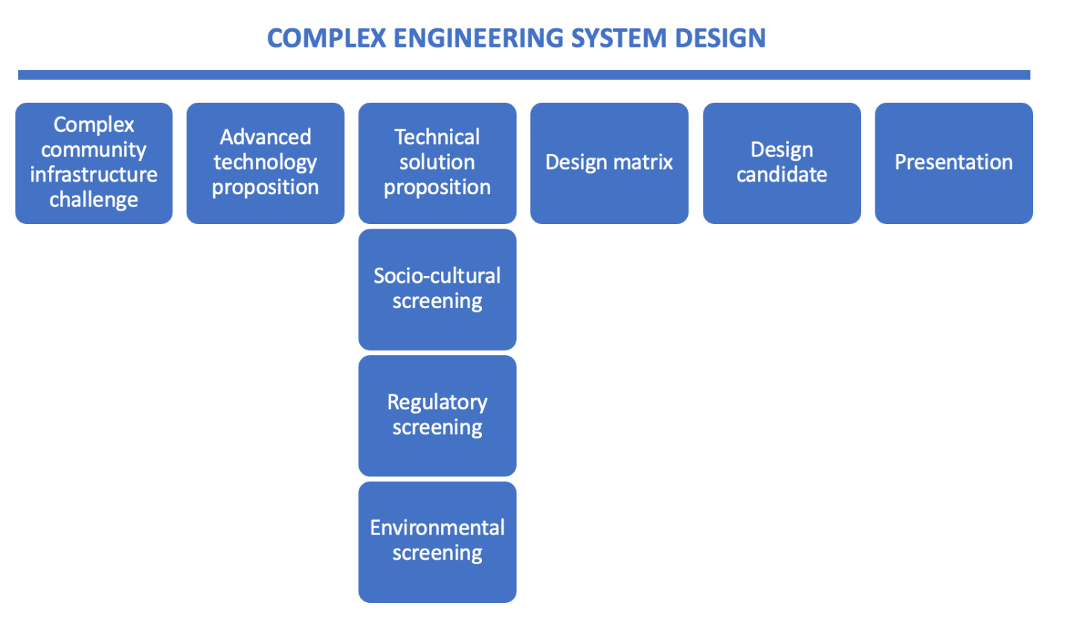

Figure 1 ENGINEER 2PX3 Design Process

Now that you have reviewed what was covered in 1P13 and learned about the general overview of 2PX3, please describe your expectations for this course in point form. What experience do you hope to gain?

|  |
| --- |
| * I hope to gain experience designing and prototyping more complex solutions * I hope to gain experience that will help me consider society, cost, and other factors when designing a solution * I hope to gain experience in a collaborative environment with a diverse team collectively working towards the same goal. I hope to learn how to harness each team member’s individual strengths to come up with a more creative and effective solution. * I hope to learn more about the system-level design process, and the key differences between it and the 1p13 design process * I hope to gain valuable experience in presenting the group’s ideas, progress, designs, and prototypes, as well as experience pitching solutions to clients |

Stage 5: Documentation

As your workload increases over the next couple of weeks, the number of documents and notes you have will increase. It is highly recommended that you use the provided worksheets to document all your ideas and progress. Even though these worksheets are marked for completion, they will guide you and keep you on track throughout this course. You are also encouraged to create a repository with all your files on OneDrive or MS Teams. You can setup a folder hierarchy and a proper naming convention to ensure you are keeping track of all your documents. As a start, please create a folder with the following files and hierarchy:

* ENGINEER 2PX3 Project Files
  + Week 1
    - Wk-1 - Asynchronous Design Studio 1 Worksheet
    - Wk-1 - Synchronous Design Studio 1 Worksheet
  + Week 2
    - Wk-2 - Asynchronous Design Studio 2 Worksheet
    - Wk-2 - Synchronous Design Studio 2 Worksheet

Please post a screenshot below of the folder hierarchy you created.

|  |
| --- |
|  |

Submission Instructions

1. Upload a *.**PDF** copy of the Wk-2 - Asynchronous Design Studio 2 Worksheet to the Avenue Dropbox titled **Asynchronous Design Studio Week 2** by Friday, Jan 21st, end of day (5:30 pm)
   * Use the following naming convention: **macID_AsynchDS2.pdf**